## Experiment [4]: [Bash Scripting]

### Name: Tushita Sharma, Roll No.: 590029121, Date: 2025-09-20

### AIM:

* [To Learn Basics of Bash Scripting.]

### Requirements:

* [Any Linux Distro, any kind of text editor (vs code, vim, notepad, nano, etc)]

### Theory:

* [Learning the basics of bash scripting.]

## Procedure & Observations

## Exercise 1: [Hello World Script]

## Task Statement:

* [Basic Usage of Shell Scripts]

## Explanation:

* [Writing Begginer level Shell Scripts]

## Command(s):

#!/bin/bash  
echo "Hello, World!"

#### Output:



## Exercise 2: [Personalized Greeting Script]

## Task Statement:

* [Basic Shell Script to callout user defined function.]

## Explanation:

* [This Shell script will take input from user and store it in a variable and then call the variable which will output the stored value.]

## Command(s):

#!/bin/bash  
echo "What is your name?"  
read name  
echo "Hello, $name! Welcome to Shell Scripting."

## Output:

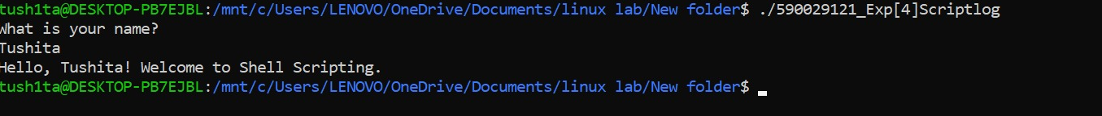

## Exercise 3: [Arithmetic Operations in Shell Scripting]

## Task Statement:

* [Using Basic Arithmetic Operations in Shell Scripts]

## Command(s):

#!/bin/bash  
echo "Enter first number: "  
read num1  
echo "Enter second number: "  
read num2  
  
echo "Addition: $((num1 + num2))"  
echo "Subtraction: $((num1 - num2))"  
echo "Multiplication: $((num1 * num2))"  
echo "Division: $((num1 / num2))"

## Output:

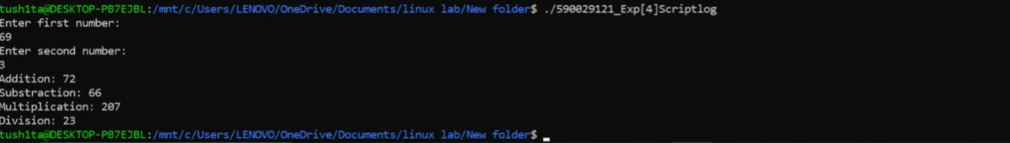

## Exercise 4:

* [Voting Eligibility]

## Task Statement:

* [Using Conditionals in Shell script ]

## Command(s):

#!/bin/bash  
echo "What is your age?"  
read age  
if [ $age -ge 18 ]; then  
  
 echo "You are eligible to vote!"  
  
else   
 echo "You are not eligible to vote!"

## Output:

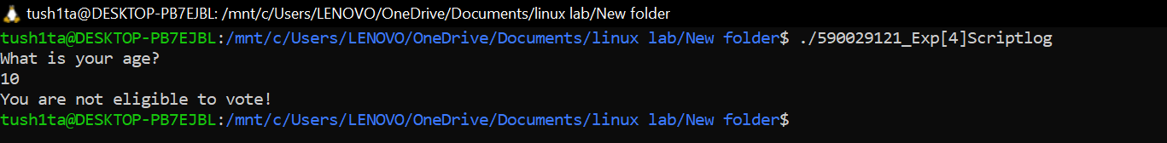

## Result

* The Exercises were successfully completed for Basic Shell Scripting.